To Show Customers Table in Company Database: -

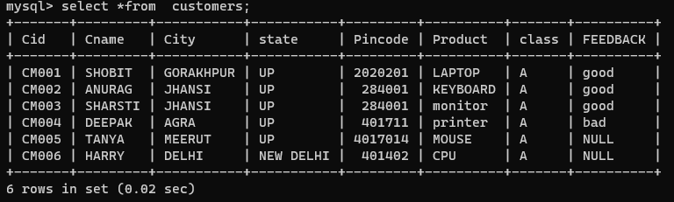

To Show salesman Table in Company Database: -

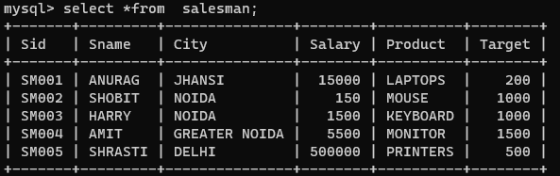

To Show orders Table in Company Database: -

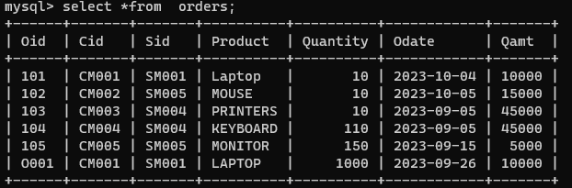

Q1. Display All Information for Salesman.

**select *from salesman;**

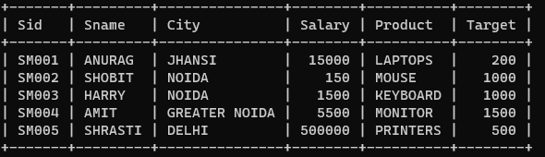

Q2. Find The name of customers lives outside Delhi.

**select *from customers where city !='Delhi';**

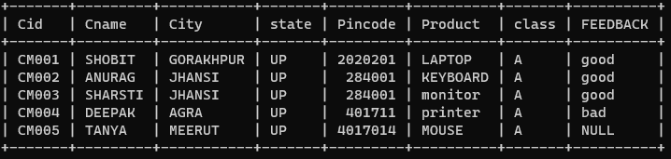

Q3. Find The name of customers lives outside Delhi.

**select *from customers where city = 'Delhi';**

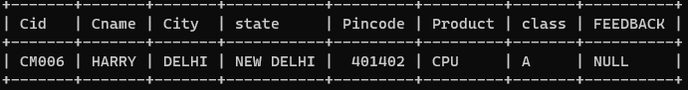

Q4. Find the name of salesman having salary greater than 20,000.

**select *from salesman where salary > 20000;**

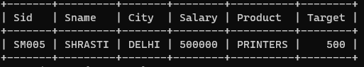

Q5. Find the SID of salesman who placed order on 26-09-2023.

**select *from orders where odate='2023-09-26';**

